Software Requirements Specification

caMOD 2.2 Iteration 1
NCICB

DOCUMENT REVISION HISTORY
Version Number | Date | Description
1.0 | June 26, 2006 | - Initial Draft for advanced search additions
1.1 | July 06, 2006 | - Combined all UC docs for iteration 1
1.2 | July 12, 2006 | - Modified as per the review comments by Ulli  - Added UC for genotype and nomenclature submission
1.3 | July 17, 2006 | - Added UC for indicating if model has associated image or micro array data  - Rearranged order to match design document order

Background/Summary
The cancer models database (caMOD) is a web-based resource that provides information about animal models for human cancer to the public research community.

caMOD provides the following key capabilities to its users:

- Data Submission--Data in caMOD are extracted from the public scientific literature by curators and verified by the scientists who generated or worked with the models, or they are directly submitted by scientists.

- Cancer Model Search--Users can retrieve information about the making of models, their genetic descriptions, histopathology, derived cell lines, associated images, carcinogenic interventions, microarray data, and therapeutic trials in which the models were used. caMOD provides links to PubMed for associated publications and other resources such as mouse repositories, detailed information about altered gene, pathway affected, and information about human clinical trials that utilize the same compounds as the pre-clinical trials in the animal models.

- System Function Administration--The Admin function provides services for user registration, review of submitted models and database management.

Table of Content
Requirements Specification 1
caMOD 2.2 Iteration 1 1
Background/Summary 1
1 Introduction 4
1.1 Overview for advanced search features 4
1.2 Overview for siRNA data 4
1.3 Overview for administration features 5
1.4 Overview for genotype and nomenclature data 5
1.5 Related Documents 5
2 Actors and Authorization 6
3 Use Cases 8
3.1 Search for Models from Jackson Laboratories (External Source) 9
3.1.1 Use Case Model 9
3.1.2 Supplemental Requirements 9
3.2 Search for Tool Strains 10
3.2.1 Use Case Model 10
3.2.2 Supplemental Requirements 10
3.3 Submit siRNA Models 11
3.3.1 Use Case Model 11
3.3.2 Supplemental Requirements 12
3.4 Search for siRNA Models 12
3.4.1 Use Case Model 12
3.4.2 Supplemental Requirements 13
3.5 Allow a Super User to Change the State of a Model 13
3.5.1 Use Case Model 13
3.5.2 Supplemental Requirements 14
3.6 Allow a Super User to Duplicate a Model from the Administration Section 14
3.6.1 Use Case Model 14
3.6.2 Supplemental Requirements 15
3.7 Allow a Super User to Delete (Inactivate) a Model from the Administration Section 15
3.7.1 Use Case Model 15
3.7.2 Supplemental Requirements 16
3.8 Allow for the Submission of Nomenclature and Genotype Information 16
3.8.1 Use Case Model 16
3.8.2 Supplemental Requirements 17
3.9 Indicate if Model has Associated Image or Micro Array Data 17
3.9.1 Use Case Model 17
3.9.2 Supplemental Requirements 18
4 General Requirements 19
4.1 Requirements Prioritization 19
5 Data Definitions 19
6 Sign Off 20
6.1 Approval 20

Introduction

Overview for advanced search features
Currently the advanced search queries allow users to search for animal models with the following criteria: by Model Name /Model Descriptor, PI's Name, Site of Lesion/Tumor, Diagnosis, Species, Phenotype, for models with Genetic Description (also by Gene Name, Transgene, Targeted Modification, Genomic Segment Designator), for models by the Inducing Agent for Induced Mutation, for models with Carcinogenic Interventions (also by Chemical/Drug Growth Factor, Hormone, Radiation, Virus, or Surgery), for models with Cell Lines, Therapeutic Approaches (also by Compound/Drug), Histopathology (also with Metastasis), for models with transient interference data, and for models with microarray data.
The users request to search for models with images, defined as Tool Mouse models, and for models from Jackson Laboratories (external source). This will require the addition of three more queries and require that each of these criteria be added to the saved queries code. A decision must be made if any of these fields will be added to the search results settings functionality. The new search for models from Jackson Lab will be implemented generically so future queries for model from outside sources will work from this functionality.

Overview for siRNA data
Currently caMOD supports the submission and display of models for Morpholino phosphorodiamidate oligonucleotides in Zebrafish species. Morpholino phosphorodiamidate oligonucleotides (MOs) are small antisense molecules (about 25 nucleotides) that are used to block regions of RNA and thus knock down a gene function. MOs are the main tool for reverse genetics in fish models.
siRNA is used in RNA silencing, a method that allows one to “knock-down” expression of genes in a sequence-specific fashion. Although RNA silencing occurs naturally to protect organisms from aberrant transcription, it is now being exploited to silence genes implicated in disease and to determine the functions of various genes.
Add the ability to submit and search for models with siRNA treatment under the section for Transient Interference in camod.

Overview for administration features
Currently the administration section in caMOD 2.1 allows the super user access to all model entries to update them. This is to facilitate minor text corrections in an entry without having to bother the submitter. No other role has this functionality.
Add the ability to change the state of a model, to duplicate a model within the administrative section, and to inactivate the model (or set to screened -rejected) so the model no longer appears on the search and most admin screens.

Overview for genotype and nomenclature data
Originally the GenotypeSummary and Nomenclature objects were associated with the EngineeredGene object in order to build an automated process to generate official nomenclature names. This automated process was never implemented. In this iteration of caMOD, the GenotypeSummary and nomenclature objects will be associated with the AnimalModel object which will allow us to collect the data from the submitter.
Add the ability to submit the genotype of the model and the official nomenclature name to the submission section of caMOD.

Related Documents

Document Name | Version | Location
caMOD - Release 2.1 - Saving Queries.doc | Variable | CVS project in the C:\dev\workspace\camod_dev\docs\artifacts\design folder
caMOD - Release 2.1 - User Search Result Settings.doc | Variable | CVS project in the C:\dev\workspace\camod_dev\docs\artifacts\design folder
caMOD_Zebrafish_DesignDocument.doc | Fixed | CVS project in the C:\dev\workspace\camod_dev\docs\artifacts\design folder
caMODRequirementsDocument-02282005.doc | Fixed | CVS project in the C:\dev\workspace\camod_dev\docs\artifacts\requirements folder

Actors and Authorization

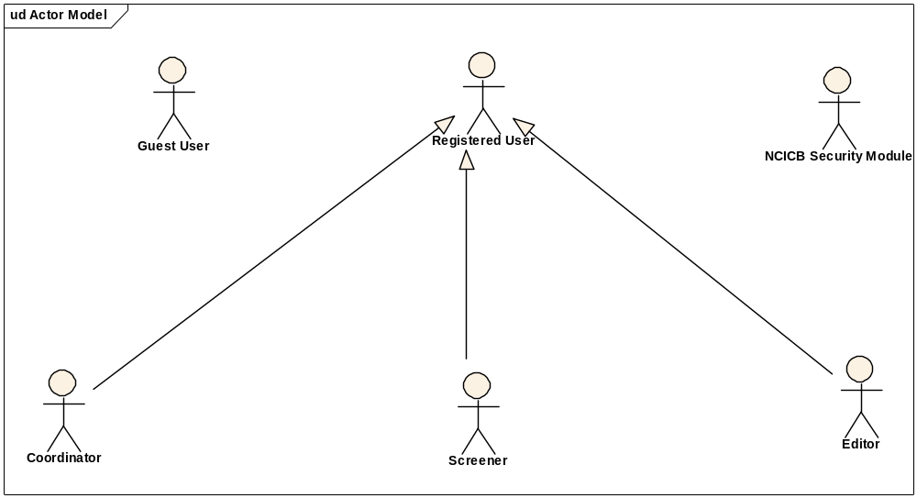
Guest User: Includes every user without an account. These users can query the database without restrictions, but they cannot submit models or comment on models.
Registered User: Can submit models to the database and can comment on models submitted by other researchers.
Super User (not shown): Has access to all model entries to update them. This is to facilitate minor text corrections in an entry without having to bother the submitter.
Coordinator: The coordinator is a registered user who appoints screener and editors. The coordinator also grants access privileges and manages the review process. After a model has been entered the coordinator assigns a screener who will check that all required fields have been specified and that the model does not contain junk or grossly inappropriate material. The coordinator will be informed about the decision of the screener by email. If the screener accepted the model the coordinator then assigns the model to an editor, who is a content expert.
Screener: The Screener is a registered user who performs the initial review of submitted models. This review is a quick check that all required fields have been specified and that the model does not contain junk or grossly inappropriate material. The screener also makes a preliminary assessment for clarity, typographic errors and other issues that would make the model less than fully comprehensible. The screening process should be complete within 24 hours. The screener does not contact the submitter about the submission. Any deficiencies found are described in the email to the coordinator. Each email deals with only one submission, so that the emails can be independently routed for vetting.
Editor: The Editor is a registered user who examines a model to see if it satisfies criteria to be made available to the public. The editor also considers any comments, made by the screener, that are passed along in the email from the coordinator. The editor may determine that the model cannot be made acceptable for publication in the database because it requires additional data. If the model has correctable defects, it may be necessary to communicate by email with the submitter to make the model acceptable. Correspondence and telephone contact with the submitters may be conducted through the coordinator. Editors are responsible for maintaining a paper trail or log of email exchanges regarding the models they review. The editor may elect to review a model without assistance. He or she can also request assistance from other subject matter experts. Only the editor has the authority to release the model to the intended audience.

Use Cases

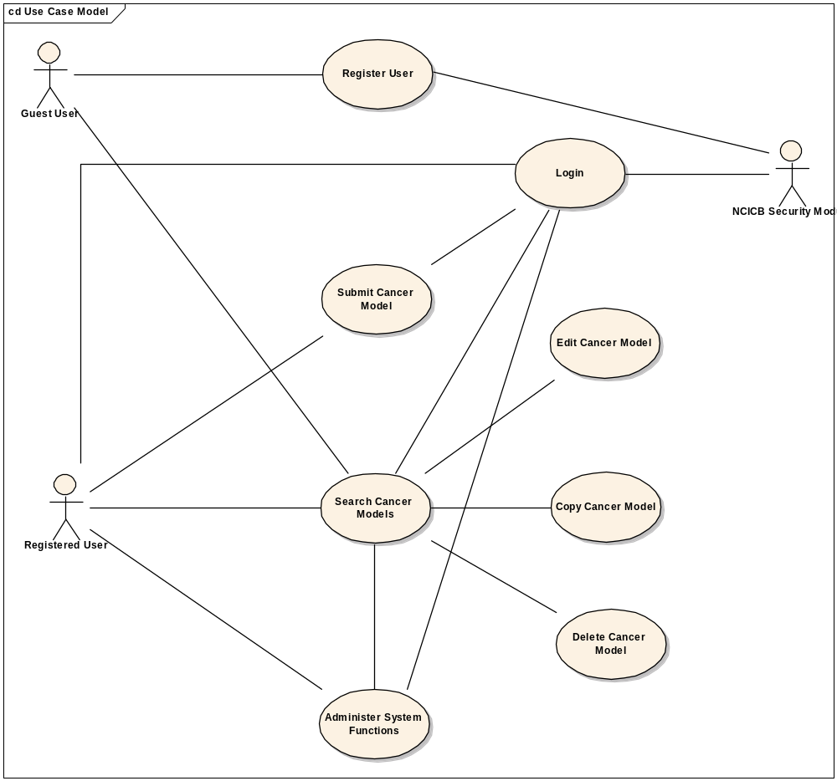
Figure 1. caMOD Use Case Diagram

Search for Models from Jackson Laboratories (External Source)

Use Case Model

Use Case Name | Search for Models from Jackson (External Source)
Use Case ID | 2
Primary Actor | All users
Brief Description | Advanced search features allow users to search by a range of variables. Add the ability to search for models with additional data from Jackson Laboratories. Make this query generic in order to add additional external sources in the future.
Trigger | Actor navigates to the caMod URL
Pre-conditions | Successful navigation to the caMod URL
Flow of Events | 1. The system presents search and submit models hyperlinks.
Flow of Events | 2. The actor
Flow of Events | a. Navigates to the search models section
Flow of Events | 3. The system
Flow of Events | - Returns the search criteria screen
Flow of Events | 4. The actor
Flow of Events | a. Enters selection criteria and submits search form
Flow of Events | 3. The system
Flow of Events | a. Returns models matching any selection criteria entered by the user
Post Conditions | Success Condition: System returns models matching selection criteria.  Error Condition: No models found  Error Condition: Validation fails  Error Condition: System Error
Alternative Courses of Action | If a validation error occurs, the system throws an exception, displays an error message and re-displays page for data entry.  a. No Models Found  -Re Submit modified search criteria (Return to step 4a)  b. System Error.  -Contact system administrator
Issues

Supplemental Requirements
1. Make sure new query is saved and configurable in the user search results functionality.

Search for Tool Strains

Use Case Model

Use Case Name | Search for Tool Strains
Use Case ID | 3
Primary Actor | All users
Brief Description | Advanced search features allow users to search by a range of variables. Add the ability to search for Tool strains from all animal models.
Trigger | Actor navigates to the caMod URL
Pre-conditions | Successful navigation to the caMod URL
Flow of Events | 1. The system presents search and submit models hyperlinks.
Flow of Events | 2. The actor
Flow of Events | a. Navigates to the search models section
Flow of Events | 3. The system
Flow of Events | - Returns the search criteria screen
Flow of Events | 4. The actor
Flow of Events | a. Enters selection criteria and submits search form
Flow of Events | 3. The system
Flow of Events | a. Returns models matching any selection criteria entered by the user
Post Conditions | Success Condition: System returns models matching selection criteria.  Error Condition: No models found  Error Condition: Validation fails  Error Condition: System Error
Alternative Courses of Action | If a validation error occurs, the system throws an exception, displays an error message and re-displays page for data entry.  a. No Models Found  -Re Submit modified search criteria (Return to step 4a)  b. System Error.  -Contact system administrator
Issues

Supplemental Requirements
1. Make sure new query is saved and configurable in the user search results functionality.

Submit siRNA Models

Use Case Model

Use Case Name | Submit siRNA Models
Use Case ID | 4
Primary Actor | All registered users
Brief Description | Camod provides interfaces for users to submit various types of data for animal models. Modify the interface for Transient Interference to allow for the submission of siRNA treatments.
Trigger | Actor navigates to the caMod URL
Pre-conditions | Successful navigation to the caMod URL  Successful login to camod
Flow of Events | 1. The system presents search and submit models hyperlinks.
Flow of Events | 2. The actor
Flow of Events | - Navigates to the new model submission section  - Successfully enters the data to create a new model
Flow of Events | 3. The system
Flow of Events | - Returns the data-type categories for submitting data
Flow of Events | 4. The actor
Flow of Events | - Navigates to the Transient Interference submission section  - Enters data for the siRNA treatment and submits form
Flow of Events | 3. The system
Flow of Events | a. Saves the data for the submitted model
Post Conditions | Success Condition: User creates new model and submits data for appropriate section.  Error Condition: Fails to create new model  Error Condition: Validation fails  Error Condition: System Error
Alternative Courses of Action | If a validation error occurs, the system throws an exception, displays an error message and re-displays page for data entry.  a. Fails to create new model  -Re Submit new model data (Return to step 2a)  -Contact system administrator  b. Validation fails  - Re-enter required data for model Return to step 2a)  c. System Error.  -Contact system administrator
Issues

Supplemental Requirements
1. Change the Morpholino object name to TransientInterference so it applies to both morpholino and siRNA models. This can be expanded in the future.
    - Modify all code that refers to the Morpholino object name (data, form, action, populateAction, managers, impls)
    - Add a single variable for method (morpholino or siRNA)
    - Create a TransientInterferenceMethod object to hold the method for the TransientInterference and implement it as a lookup table. The TransientInterferenceMethod will have a one to one relationship to the TransientInterference object and be comprised of the following attributes: id, name, and conceptCode. This can be expanded easily.
    - Save and retrieve the TransientInterference by a concept code for the method.

Search for siRNA Models

Use Case Model

Use Case Name | Search for siRNA Models
Use Case ID | 5
Primary Actor | All users
Brief Description | Advanced search features allow users to search by a range of variables. Add the ability to search for models with additional data from Jackson Laboratories. Make this query generic enough to add additional external sources in the future.
Trigger | Actor navigates to the caMod URL
Pre-conditions | Successful navigation to the caMod URL
Flow of Events | 1. The system presents search and submit models hyperlinks.
Flow of Events | 2. The actor
Flow of Events | a. Navigates to the search models section
Flow of Events | 3. The system
Flow of Events | - Returns the search criteria screen
Flow of Events | 4. The actor
Flow of Events | a. Enters selection criteria for Transient Interference and submits search form
Flow of Events | 3. The system
Flow of Events | a. Returns models matching any selection criteria entered by the user
Post Conditions | Success Condition: System returns models matching selection criteria.  Error Condition: No models found  Error Condition: Validation fails  Error Condition: System Error
Alternative Courses of Action | If a validation error occurs, the system throws an exception, displays an error message and re-displays page for data entry.  a. No Models Found  -Modify search criteria and submit again (Return to step 4a)  b. Validation fails  - Retype required data (Return to step 2a)  c. System Error.  -Contact system administrator
Issues

Supplemental Requirements
1. Search by TransientInterferenceMethod (morpholino or siRNA) and indicate this on the search results screen.

Allow a Super User to Change the State of a Model

Use Case Model

Use Case Name | Allow a Super User to Change the State of a Model
Use Case ID | 6
Primary Actor | Super Users
Brief Description | A super user has access to all model entries to update them. This is to facilitate minor text corrections in an entry without having to bother the submitter. Add the ability to change the state of models to the super user’s list of rights.
Trigger | Actor navigates to the caMod URL
Pre-conditions | Successful navigation to the caMod URL and logs into the system
Flow of Events | 1. The system presents a link for the admin section for authorized users (including super users).
Flow of Events | 2. The actor
Flow of Events | a. Navigates to the admin section
Flow of Events | 3. The system
Flow of Events | - Returns a list of models to be screened and provides links for additional administration features.
Flow of Events | 4. The actor
Flow of Events | a. Selects the Edit Models hyperlink
Flow of Events | 5. The system
Flow of Events | a. Returns all the models in the system from all states
Flow of Events | 6. The actor
Flow of Events | a. Selects a models to edit
Flow of Events | 7. The system
Flow of Events | a. Returns the current model’s status
Post Conditions | Success Condition: Super user changes state for model without error.  Error Condition: State not changed  Error Condition: System Error
Alternative Courses of Action – | - State not changed  -Contact system administrator  - System Error.  -Contact system administrator
Issues

Supplemental Requirements
    - Allow super user to modify the state from the model status screen.
    - Extra: Display some basic model information to assure the user selected the model correctly.
    - Return the super user to the Edit Models list to select another model.

Allow a Super User to Duplicate a Model from the Administration Section

Use Case Model

Use Case Name | Allow a Super User to Duplicate a Model from the Administration Section
Use Case ID | 7
Primary Actor | Super Users
Brief Description | A super user has access to all model entries to update them. This is to facilitate minor text corrections in an entry without having to bother the submitter. The system allows the submitter to delete and duplicate the model from the submission section of caMOD. Add the ability to duplicate the model from the administration section to the super user’s list of rights.
Trigger | Actor navigates to the caMod URL
Pre-conditions | Successful navigation to the caMod URL and logs into the system
Flow of Events | 1. The system presents a link for the admin section for authorized users (including super users).
Flow of Events | 2. The actor
Flow of Events | a. Navigates to the admin section
Flow of Events | 3. The system
Flow of Events | - Returns a list of models to be screened and provides links for additional administration features.
Flow of Events | 4. The actor
Flow of Events | a. Selects the Edit Models hyperlink
Flow of Events | 5. The system
Flow of Events | a. Returns all the models in the system from all states
Post Conditions | Success Condition: Super user duplicates the model without error.  Error Condition: Model not duplicated or inactivated  Error Condition: System Error
Alternative Courses of Action – | a. Model not duplicated or inactivated  -Contact system administrator  b. System Error.  -Contact system administrator
Issues

Supplemental Requirements
1. Change the name of the duplicated model from “Copy of x” to “x (Copy)” so the sorting of models will not separate this model from the original one. The copy will be displayed below the original model and be easy to find.
2. On the Edit Models screen, add the duplicate button. Make this page look like the submitNewModels screen.

Allow a Super User to Delete (Inactivate) a Model from the Administration Section

Use Case Model

Use Case Name | Allow a Super User to Delete (Inactivate) a Model from the Administration Section
Use Case ID | 8
Primary Actor | Super Users
Brief Description | A super user has access to all model entries to update them. This is to facilitate minor text corrections in an entry without having to bother the submitter. The system allows the submitter to delete and duplicate the model from the submission section of caMOD. Add the ability to delete (inactivate) the model from the administration section to the super user’s list of rights.
Trigger | Actor navigates to the caMod URL
Pre-conditions | Successful navigation to the caMod URL and logs into the system
Flow of Events | 1. The system presents a link for the admin section for authorized users (including super users).
Flow of Events | 2. The actor
Flow of Events | a. Navigates to the admin section
Flow of Events | 3. The system
Flow of Events | - Returns a list of models to be screened and provides links for additional administration features.
Flow of Events | 4. The actor
Flow of Events | a. Selects the Edit Models hyperlink
Flow of Events | 5. The system
Flow of Events | a. Returns all the models in the system from all states
Post Conditions | Success Condition: Super user deletes (inactivates) the model without error.  Error Condition: Model not duplicated or inactivated  Error Condition: System Error
Alternative Courses of Action – | a. Model not duplicated or inactivated  -Contact system administrator  b. System Error.  -Contact system administrator
Issues

Supplemental Requirements
1. On the Edit Models screen, add the delete (inactivate) button. Make this page look like the submitNewModels screen.
2. Do not delete, but instead move the model to “Screened’Rejected” state. Allow super user to comment why the model state was changed. This removes the model from being displayed to the users.

Allow for the Submission of Nomenclature and Genotype Information

Use Case Model

Use Case Name | Allow for the Submission of Nomenclature and Genotype Information
Use Case ID | 9
Primary Actor | All registered users
Brief Description | Currently caMOD provides interfaces for users to submit various types of data for animal models. Currently, the nomenclature and genotype summary objects are associated to the engineered gene object. This does not allow for the submission of genotype and nomenclature data associated with an animal model. Modify the association for these objects and modify the interface to allow for the submission of nomenclature and genotype data.
Trigger | Actor navigates to the caMod URL
Pre-conditions | Successful navigation to the caMod URL  Successful login to caMOD
Flow of Events | 1. The system presents search and submit models hyperlinks.
Flow of Events | 2. The actor
Flow of Events | - Navigates to the new model submission section  Successfully enters the data to create a new model including the genotype and nomenclature data
Flow of Events | 3. The system
Flow of Events | - Returns the data-type categories for submitting data
Post Conditions | Success Condition: User creates new model and submits data for appropriate section.  Error Condition: Fails to create new model  Error Condition: Validation fails  Error Condition: System Error
Alternative Courses of Action | If a validation error occurs, the system throws an exception, displays an error message and re-displays page for data entry.  a. Fails to create new model  -Re Submit new model data (Return to step 2a)  -Contact system administrator  b. Validation fails  - Re-enter required data for model Return to step 2a)  c. System Error.  -Contact system administrator
Issues

Supplemental Requirements
1. Remove the association between the GenotypeSummery and the EngineeredGene and replace it with an association between the GenotypeSummery and the AnimalModel object. Make one to one relationship.
2. In the GenotypeSummery table delete the genotype field (genotype not used).
3. Make the association between nomenclature and GenotypeSummery a one to one association.

Indicate if Model has Associated Image or Micro Array Data

Use Case Model

Use Case Name | Indicate if Model has Associated Image or Micro Array Data
Use Case ID | 10
Primary Actor | All users
Brief Description | Advanced search features allow users to search by a range of variables. The search results page lists the models matching user criteria by Model Description, Tumor Sites, and Species. Add an indication if the model has associated Image or Micro Array data.
Trigger | Actor navigates to the caMod URL
Pre-conditions | Successful navigation to the caMod URL
Flow of Events | 1. The system presents search and submit models hyperlinks.
Flow of Events | 2. The actor
Flow of Events | a. Navigates to the search models section
Flow of Events | 3. The system
Flow of Events | - Returns the search criteria screen
Flow of Events | 4. The actor
Flow of Events | a. Enters selection criteria and submits search form
Flow of Events | 3. The system
Flow of Events | a. Returns models matching any selection criteria entered by the user including an indication if each model has associated image or micro array data
Post Conditions | Success Condition: System returns models matching selection criteria.  Error Condition: No models found  Error Condition: Validation fails  Error Condition: System Error
Alternative Courses of Action | If a validation error occurs, the system throws an exception, displays an error message and re-displays page for data entry.  a. No Models Found  -Re Submit modified search criteria (Return to step 4a)  b. System Error.  -Contact system administrator
Issues

Supplemental Requirements
- Add icons in the Model descriptor column, separated by a break.
- Add one icon for images and one for micro array data.

General Requirements

Requirements Prioritization

Req # | Supp Req Ref # | Use Case Name | Priority
380 |  | Search for models with additional data from Jackson Laboratories (external Source) | High
395 |  | Search for models defined as Tool Mouse models | High
385 |  | Submit and Search siRNA models | High
389 |  | Super User will be allowed to change the state of a model | High
390 |  | Super User will be allowed to duplicate models from the administration section | High
390 |  | Super User will be allowed to delete (inactivate) models from the administration section | High
356 |  | Find a solution for entering the nomenclature and genotype information | High
396 |  | Indicate if a model has associated image or micro array data. | High

Data Definitions

CDE # | Data Element | Description | Use Case Name

Sign Off

Approval

Workspace General Contractor Rep Print Name Date
Architecture Workspace Rep Print Name Date
VCDE Workspace Rep Print Name Date
Workspace Working Group Rep Print Name Date
NCICB Rep Print Name Date

